**FSN21218P: Analysis of Foodborne Pathogens**

**Objectives:**

This course will expose learners to

* Techniques of isolating bacteria and identifying bacteria;
* Methods of antibiotic sensitivity testing and viable microbial count in food.

**Learning Outcomes:**

Upon completion of this course, the learners would be able to

* Isolate and identify bacteria;
* Test antibiotics sensitivity against pathogens;
* Count viable microbes in food.

**Content:**

1. Aseptic culture technique

2. Method of isolation of pure culture

3. Identification of bacteria by Gram-staining

4. Antibiotics sensitivity testing

5. Isolation and identification of common food borne pathogens.

6. Determination of number of viable microorganisms in food sample.

7. Microbial testing of water

Introduction

**Microbiology:** Microbiology is the branch of biology that deals with the study of microorganisms, which are microscopic organisms such as bacteria, viruses, fungi, Achaea, and protists.

**Microorganism:** Different kind of live microscopic organism are discussed in microbiology. Living organism are divided into 5 kingdoms on the basis of complexity of cell, complexity of organism, mode of nutrition.

1. complexity of cell: Prokaryotes and Eukaryotes
2. complexity of organism: Unicellular, Multicellular
3. Mode of Nutrition: Autotrophic (photosynthesis) plant, saprophytic (absorption form dead body) fungus, heterotrophic (invective) Animal.

Cell wall present

Can’t perform photosynthesis

No organized nucleus

Cell wall present

Can perform photosynthesis

No cell wall

Eukaryotes other than fungi, algae, animalia

**Common microorganism responsible for food spoilage:**

* **Bacteria:**
* *Gram-negative bacteria:* Pseudomonas, Salmonella, Escherichia coli (E. coli)
* *Gram-positive bacteria:* Bacillus, Clostridium, Lactobacillus
* **Molds:**
* *Aspergillus species:* A. flavus, A. niger
* *Penicillium species:* P. roqueforti, P. camemberti
* *Rhizopus species:* R. stolonifer
* **Yeasts:**

1. *Saccharomyces cerevisiae*
2. *Candida species:* C. albicans, C. tropicalis

Lab Equipment

**Microbiology Lab equipment:**

1. Microscope
2. Incubator
3. Autoclave
4. Centrifuge
5. Biosafety Cabinet
6. Sprit lamp/ Bunsen Burner
7. pH Meter
8. Petri Dishes
9. Inoculation Loop
10. Micropipettes
11. Microbial Identification Systems
12. PCR Machine (Thermal Cycler)
13. Gel Electrophoresis Equipment
14. Microbial Fermenters
15. Different kind of media ingredients

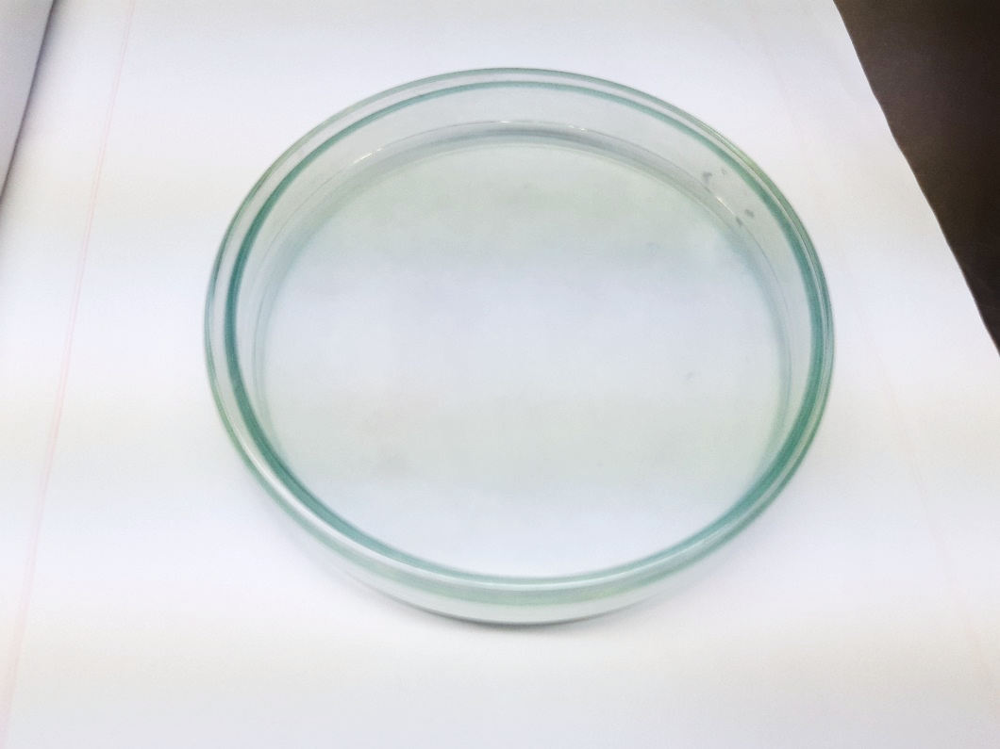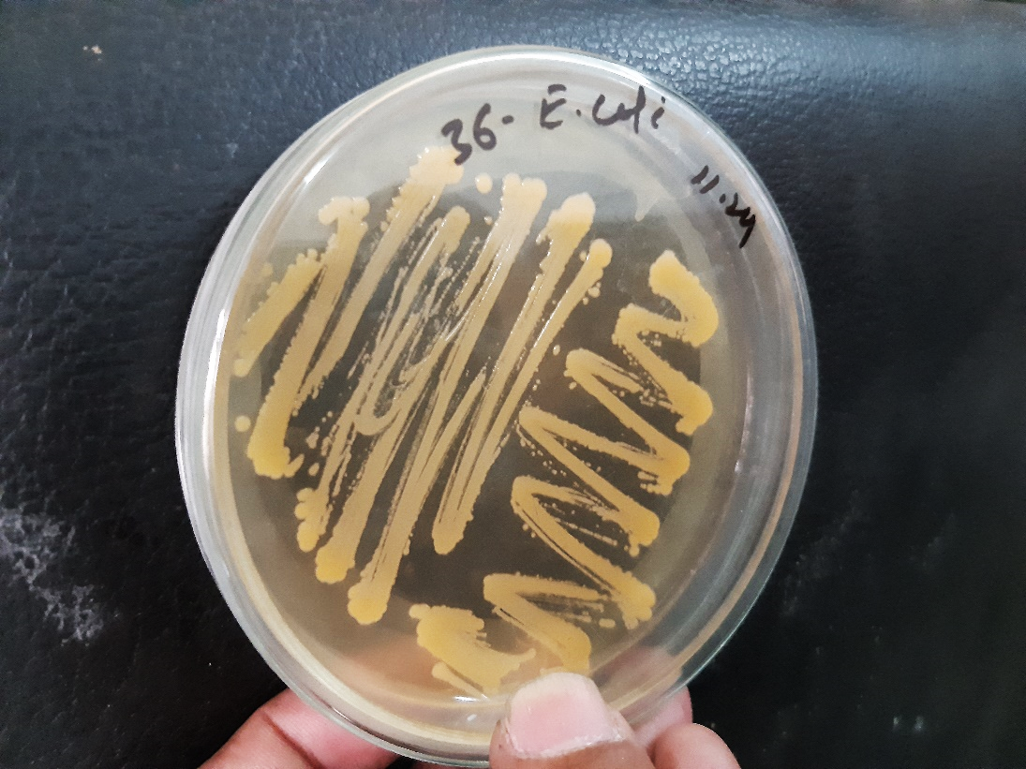

Petri dishes (Used for culturing and isolating microorganisms on solid media)

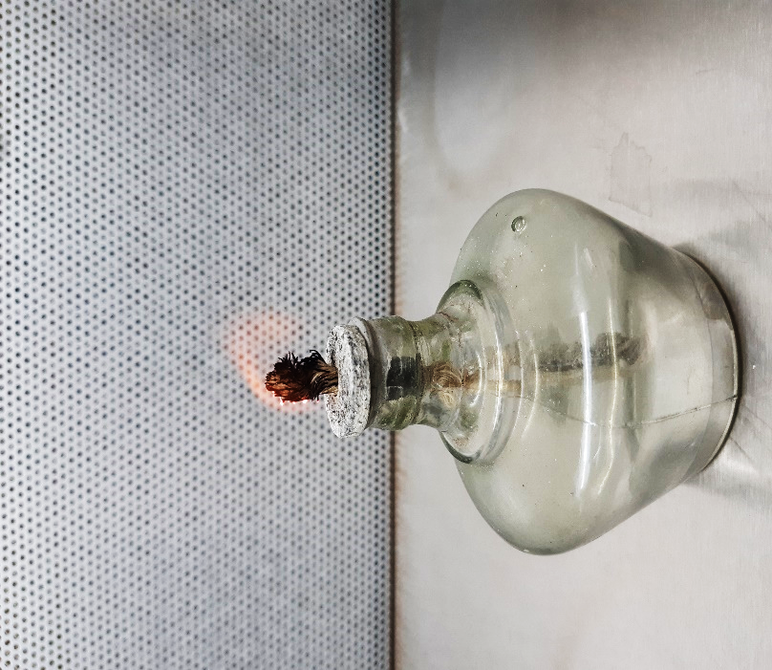 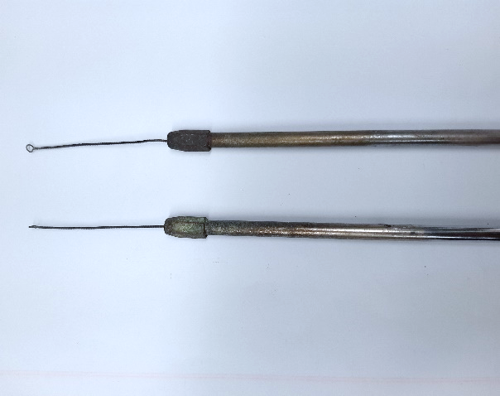

Inoculation loop (Used for transferring and streaking microorganisms onto culture media)

Spirit lamp (Used for sterilizing tools and the opening of culture tubes and petri dishes by flaming)

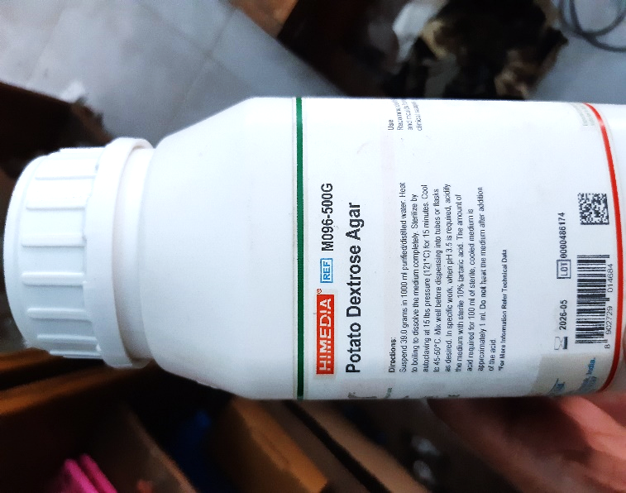 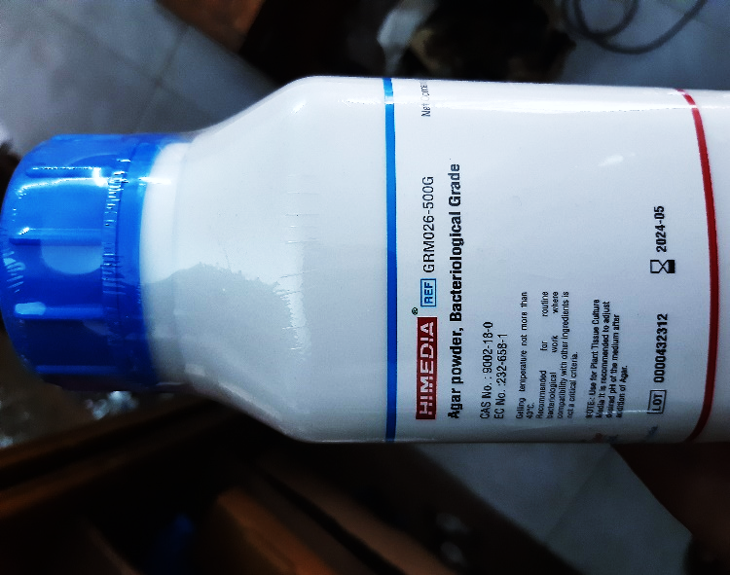

Media ingredients

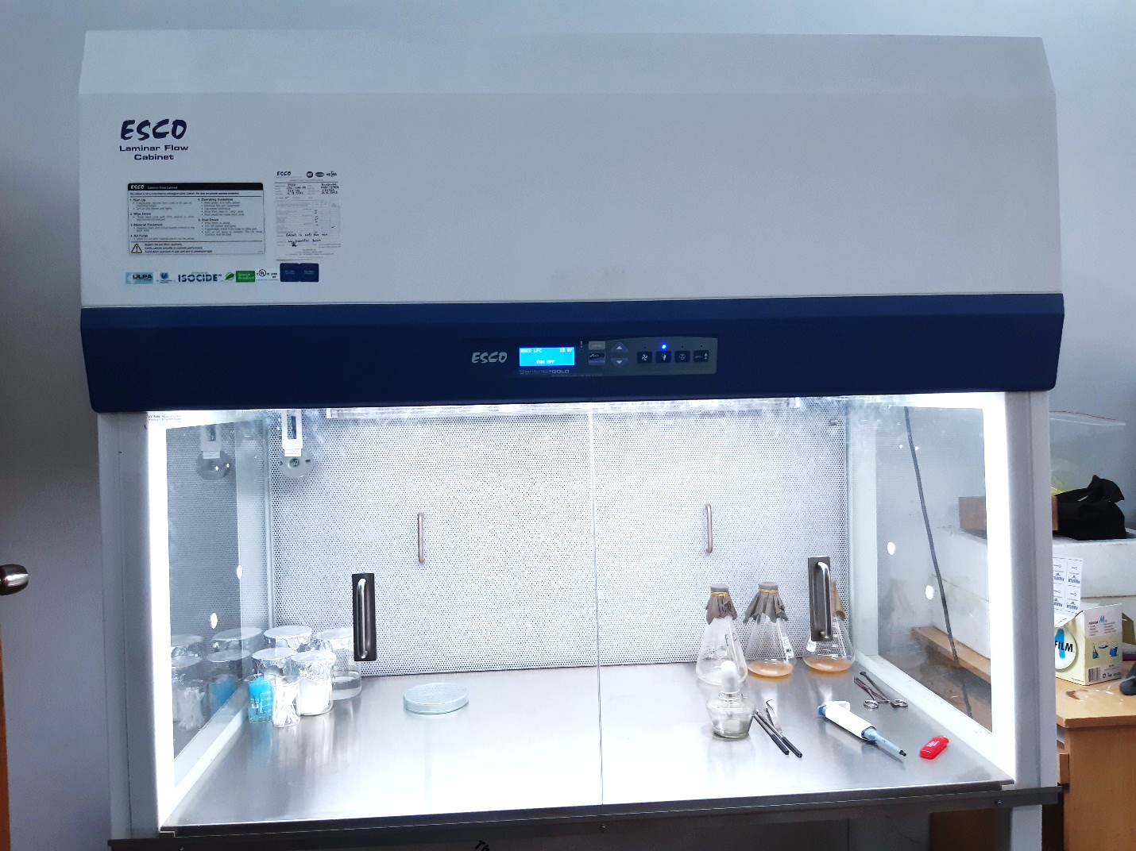

Biosafety Cabinet (Provides a sterile and enclosed environment for handling potentially hazardous microorganisms)

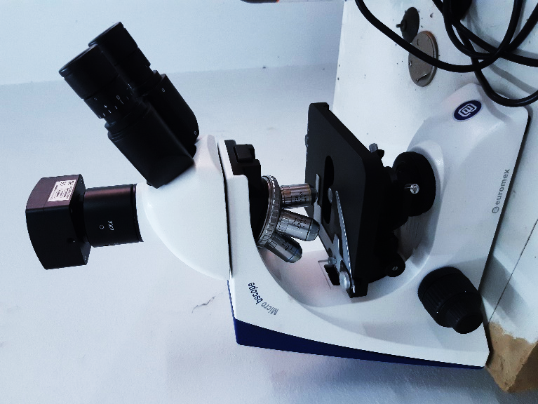

Microscope

Used for observing small specimens or cells at high magnification

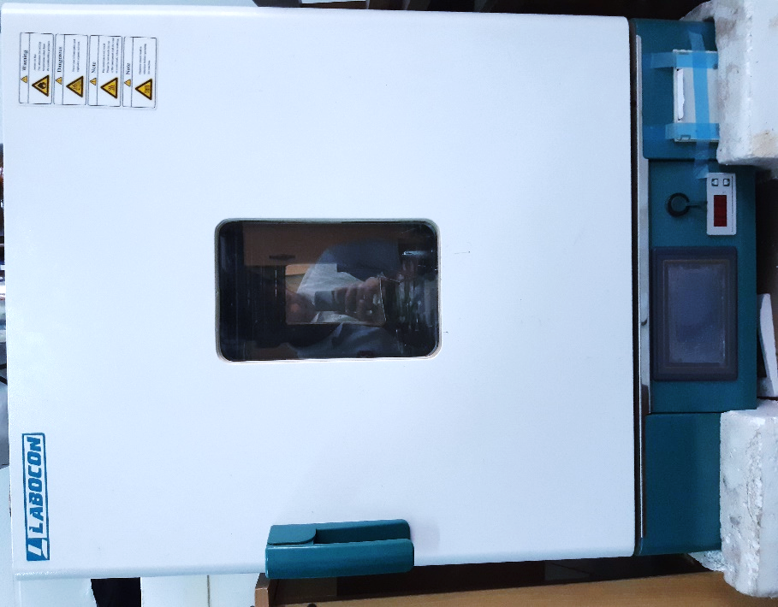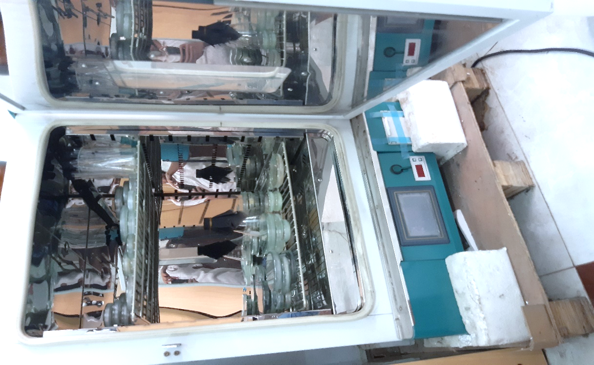

Incubator (Maintain controlled temperature and humidity for the cultivation and growth of microorganisms)

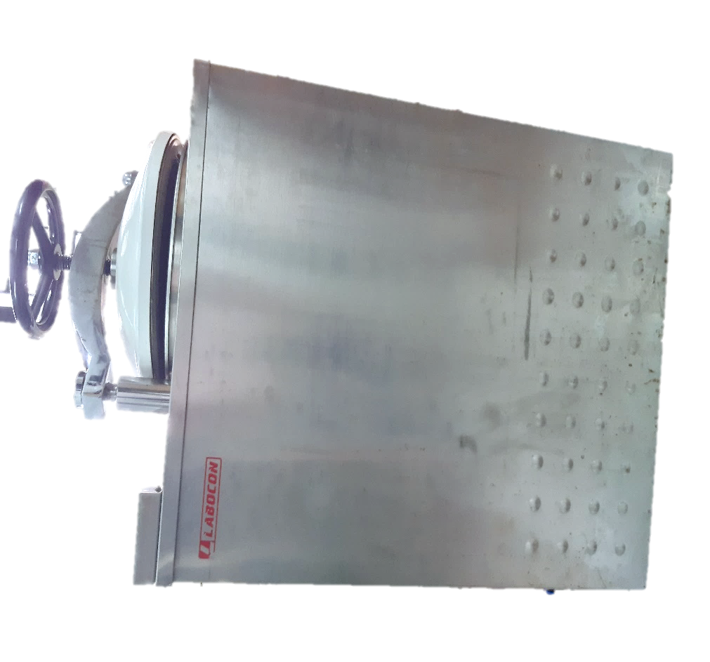

Autoclave

Sterilization equipment that uses high-pressure steam to kill bacteria, viruses, fungi, and spores on lab equipment and media

Culture Media

The food materials on which the organism is grown is known as culture medium and the growth of organism is known as culture. Different microorganisms require different nutrient materials. Thus, culture media vary in form and composition, depending upon the species to be cultivated.

**Basic Requirements of Culture Medium**

* Energy source
* Carbon source
* Nitrogen source
* Salts
* Adequate oxidation
* Growth factors

**Common Ingredients of Culture Media**

1. Water: Essential for existence of living cells.
2. Peptone: Obtained from meat, casein fibrin or soya flour. Acts as nitrogen source, carbon source, buffers
3. Meat Extract: Contains protein degradation products, carbohydrates. Source of growth factors (Vitamin B), inorganic salts etc.
4. Yeast Extract: Contains proteins, amino acids, growth factors (Vitamin B), Carbohydrates and inorganic salts like potassium and phosphates.
5. Electrolyte: Mainly used are sodium chloride or other electrolytes. Maintain the osmotic pressure
6. Agar: Dried mucilaginous substance obtained from gelidium and other algae; contains mainly long chain polysaccharides, protein like material and inorganic salts. Functions: it melts at 98 $℃$ and solidifies at 42 $℃$, hence used as solidifying agent.
7. Fermentable Compounds: Mainly used are sugars, alcohols etc. act as source of energy,
8. Buffers: Carbonates and phosphates are used as buffer to resist change in pH of the medium.

**Types of Media**

Based on consistency culture media can be classified as:

* Liquid Media
* Semi Solid Media
* Solid Media
  1. **Liquid Media or Broth**

No solidifying agents (e.g. agar) is added while preparing the medium. The most commonly used non-synthetic liquid media are nutrient broth, peptone solution, milk, blood, serum etc. Used for obtaining bacterial growth from blood or water when large volumes have to be tested.

* 1. **Semi-Solid Media**

It is prepared by adding small amount of agar (0.5%) or gelatin. Agar forms a colloidal solution in hot water and sets in the form of a jelly when cool. This type of medium can be used to study bacterial motility

* 1. **Solid Media**

It is prepared by adding 2% or 1% gelatin. It's used for colony characterization, colony identification, etc. e.g. Agar plates, slants, deeps.

**Based on purpose, culture media can be classified into:**

* Simple Media
* Enriched media
* Selective media
* Selective media
* Differential media

1. Simple Media: General-purpose medium used for the cultivation of a wide variety of microorganisms. E.g. Nutrient broth, nutrient agar
2. Enriched Media: Contains additional nutrients to support the growth of fastidious organisms. In these media, substances like blood, serum or egg are added. E.g. Blood agar, chocolate agar etc.
3. Selective Media: Contains inhibitors to select for the growth of specific groups of microorganisms. E.g. MacConkey agar, Mannitol Salt agar.
4. Differential Media: Allows for the differentiation of microorganisms based on their biochemical characteristics. E.g. Blood agar (hemolysis patterns), EMB agar (lactose fermentation).

Plating techniques

The common plating techniques employed in microbiology are Streak Plate Method, Spread Plate Method and Pour Plate Method.

1. Streak Plate Method

This method is routinely employed for the isolation of bacteria in pure culture. In this method a sterilized inoculating loop is dipped into a suitable diluted suspension of microorganisms which is then streaked on the surface of an already solidified agar plate to make a series of parallel, non-overlapping streaks.

The main objective of the streak plate method is to produce well separated colonies of bacteria from concentrated suspensions of cells.

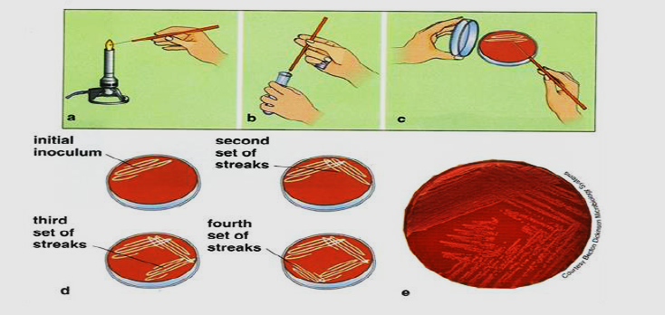

1. Spread Plate Method

The spread plate technique is used for the separation of a dilute, mixed population of the microorganisms so that individual colonies can be isolated. In this technique, a small volume of dilute microbial mixture is transferred to the center of an agar plate and spread evenly over the surface. The dispersed cells will develop into isolated colonies. Because the number of colonies will be equal to the number of viable organisms in the sample spread plates can be used to count the microbial population.

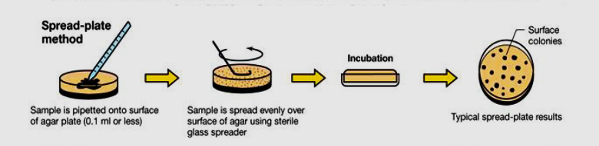

1. Pour Plate Method

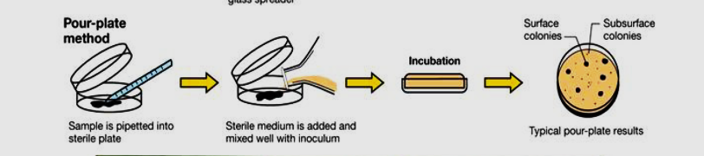

In pour plate method, successive dilutions of the inoculum (serially diluting the original specimen) are added into sterile petri plate to which is poured melted and cooled (420C - 450C) agar medium and thoroughly mixed by rotating the plates which is then allowed to solidify. After incubation, the plates are examined for the presence of individual colonies. The pure colonies may be isolated and transferred into test tube culture media for making pure cultures. This technique is employed to estimate the viable bacterial count in a suspension.

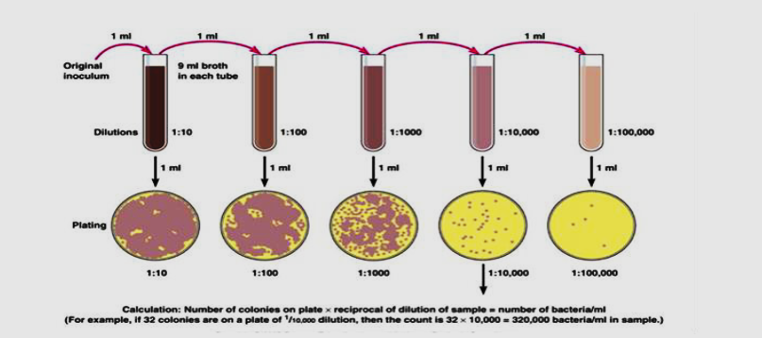

Isolating a pure culture

Isolating a pure culture involves separating a single species of microorganism from a mixed culture, allowing researchers to study it in a controlled environment. The streak plate method is a commonly used technique for isolating pure cultures. Here's a step-by-step guide to the streak plate method:

1. **Prepare Materials:**
   * Gather the necessary materials, including the mixed culture, a sterile agar plate, an inoculating loop or sterile swab, and a Bunsen burner.
2. **Sterilize the Inoculating Loop:**
   * Heat the inoculating loop in the flame of the Bunsen burner until it becomes red hot. This sterilizes the loop and prevents contamination.
3. **Inoculate the First Quadrant:**
   * Touch the loop to a small portion of the mixed culture and streak it across one-fourth of the agar surface. Use a back-and-forth motion to spread the microorganisms thinly.
4. **Sterilize the Inoculating Loop Again:**
   * Sterilize the inoculating loop by passing it through the flame. Ensure it is red hot before proceeding to the next step.
5. **Inoculate the Second Quadrant:**
   * Start from the endpoint of the first quadrant and streak a small portion into the second quadrant, using a zigzag motion. This motion dilutes the number of cells and separates them.
6. **Sterilize the Inoculating Loop Again:**
   * Sterilize the loop once more by passing it through the flame.
7. **Inoculate the Third Quadrant:**
   * Start from the endpoint of the second quadrant and streak a small portion into the third quadrant, using the same zigzag motion.
8. **Sterilize the Inoculating Loop Again:**
   * Sterilize the loop.
9. **Inoculate the Fourth Quadrant:**
   * Start from the endpoint of the third quadrant and streak a small portion into the fourth quadrant.
10. **Incubate the Plate:**
    * Invert the plate and incubate it at the appropriate temperature for the microorganism you are isolating. This allows colonies to develop.
11. **Examine and Isolate Pure Colonies:**
    * After incubation, observe the colonies on the plate. Choose well-isolated colonies from the fourth quadrant that appear to be pure cultures.
12. **Subculture for Further Isolation (if needed):**
    * If necessary, transfer a sample from one of the well-isolated colonies to a new agar plate to achieve further isolation and purity.

By repeating the streaking process, microbial colonies are further separated until a pure culture is obtained. This method helps researchers study individual microorganisms without the influence of other species.

Antibiotic sensitivity testing

Antibiotic sensitivity testing, also known as antimicrobial susceptibility testing, is a laboratory technique used to determine the effectiveness of antibiotics against specific bacterial strains. The goal is to identify which antibiotics are most likely to be effective in treating a bacterial infection. Here's a general overview of the process:

1. **Isolation of the Bacterial Strain:**
   * Before performing sensitivity testing, the target bacterial strain needs to be isolated from a clinical sample, such as blood, urine, or a wound swab.
2. **Inoculation of Culture Media:**
   * The isolated bacteria are then inoculated onto a solid culture medium, such as Mueller-Hinton agar. The bacteria are spread evenly across the surface of the agar.
3. **Application of Antibiotic Discs:**
   * Sterile paper discs impregnated with specific concentrations of different antibiotics are placed onto the agar surface. Each disc contains a single antibiotic or a combination of antibiotics.
4. **Incubation:**
   * The agar plate is incubated at a specific temperature for a defined period, typically 16-18 hours. This allows the bacteria to grow and form a visible bacterial lawn on the agar.
5. **Measurement of Inhibition Zones:**
   * After incubation, the plate is examined for zones of inhibition around each antibiotic disc. The zones represent areas where bacterial growth has been inhibited by the antibiotic.
6. **Interpretation of Results:**
   * The size of the inhibition zone is measured and compared to standardized guidelines provided by organizations such as the Clinical and Laboratory Standards Institute (CLSI) or the European Committee on Antimicrobial Susceptibility Testing (EUCAST). The results indicate whether the bacteria are sensitive, intermediate, or resistant to a particular antibiotic.
7. **Reporting Results:**
   * The results of antibiotic sensitivity testing are reported to healthcare providers. Sensitivity implies that the antibiotic is likely to be effective against the bacterial strain, resistance indicates ineffectiveness, and intermediate sensitivity suggests that the antibiotic may be effective at higher doses.
8. **Clinical Decision-Making:**
   * Healthcare professionals use the sensitivity testing results to guide the selection of appropriate antibiotics for treating the bacterial infection. This helps in choosing the most effective and targeted antibiotic therapy, minimizing the risk of antibiotic resistance.

It's important to note that sensitivity testing is specific to bacteria and may not be applicable to other microorganisms like viruses or fungi. Additionally, testing conditions, including incubation time and temperature, must be standardized to ensure accurate and reproducible results.

**Steps in part-1**

Step-01: culture media preparation

Step-02: sample preparation

Step-03: non-selective enrichment

Step-04: selective enrichment

Step-05: isolation of bacteria

Step-06: selection of bacteria

**Culture Media preparation**

1. Bismuth bisulphite agar (BSA)
2. Rappaport Vassiliadis soy broth (RSV)
3. MKTTn broth
4. X.L.D Agar

**Xylose Lysine Deoxycholate (XLD) Agar**

1. Dissolve 5.668g XLD Agar powder into 100ml distilled Water.
2. Heat at boiling point for 2 minutes & stir to dissolve the medium completely.
3. Distribute 18ml into sterile petri dishes and cool to solidify.

**Bismuth Sulphite Agar (BSA)**

1. Dissolve 5.232g Bismuth Sulphite Agar powder into 100ml Distilled Water.
2. Heat at boiling point for 2 minutes & stir to dissolve the medium completely.
3. Distribute 18ml into sterile petri dishes and cool to solidify.

**Buffered Peptone Water (BPW)**

1. Dissolve 25.5g Buffered Peptone Water powder into 1000ml Distilled Water.
2. Autoclave at 1210C temperature and 15 lbs pressure for 15 minutes.

**Rappaport Vassiliadis Soya (RVS) Broth**

1. Dissolve 2.71g RVS Broth powder into 100ml Distilled Water.
2. Heat to dissolve the medium completely and distribute 10ml into Glass Test Tubes.
3. Sterile by autoclaving at 115 ℃ and 15 lbs pressure for 15 minutes.

**Muller-Kauffmann Tetrathionate Novobiocin (MKTTn) Broth**

1. Dissolve 89.4g MKTTn Broth powder into 1000ml Distilled Water.
2. Heat the Medium to Just Boiling and cool it at 45- 48℃. Add 1 vial of MKTTn supplement (FD203) and 20ml iodine-iodide Solution.
3. Distribute 10 ml into glass test tubes.

**Sample preparation**

1. Take about 25g sample into a sterile bag and label the bag with sample name.
2. Take the sample in a biosafety cabinet.
3. Measure 225 ml buffered peptone water aseptically and pour it into the bag.
4. Shake the bag to mix the content, vortex the mixture to homogenize the sample for 15 sec.
5. Now incubate the mixture at 37 ℃ for 24h for non-selective enrichment.

**Procedure:**

1. We will use RSV and MKTTn broth for selective enrichment of salmonella.
2. Shake the bag to mix the culture properly and transfer 1 ml buffered peptone water enrichment culture into MKTTn broth and attach the cap loosely.
3. Transfer 0.1 ml buffered peptone water enrichment culture into RSV broth and attach the cap loosely.
4. Now, vortex both test tube for 10 seconds and
5. Incubate the MKTTn broth at 37℃ and RSV broth at 41.5℃ for 24 h for selective enrichment.
6. After incubation, take out RSV and MKTTn broth cultures.
7. Now streaking from RVS Enrichment on BSA Plate for Trial-1 and Trial-2 plates.
8. Streaking from RVS Enrichment on XLD Plate for Trial-I and Trial-2 plates.
9. Streaking from MKTTn enrichment on BSA plate and XLD plate.
10. Now incubate the inoculated XLD & BSA plates at 37℃ for 24.

**Observation:**

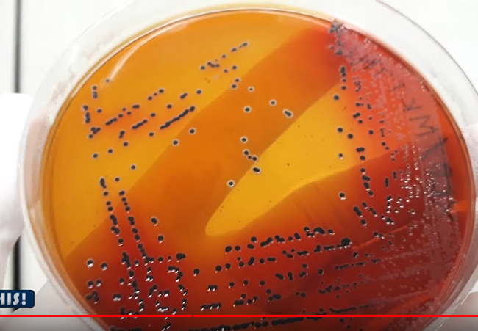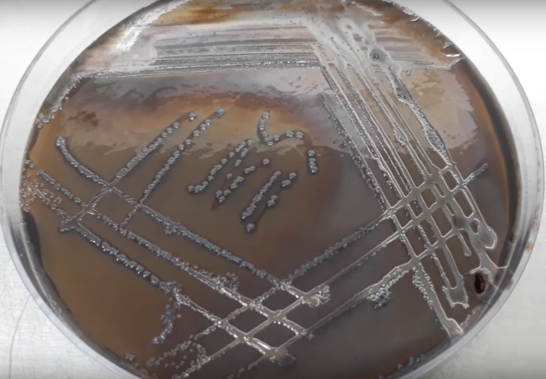

|  |  |
| --- | --- |
| *Black colonies on XLD plate are primarily considered as Salmonella spp.* | *Black to grey colonies turned the BSA media color into black. These black or grey colonies are primarily considered as salmonella spp.* |

**Part 2: Biochemical Identification**

Step-01: media preparation

Step-02: reagent preparation

Step-03: pure culture preparation

Step-04: biochemical tests

Step-05: result observation

Step-06: result interpretation

**Required Medias**

1. Triple Sugar Iron (TSI) Agar
2. MR-VP Medium
3. Simmon Citrate Agar
4. LIM Medium
5. Urea Agar

**Reagents**

1. For Indole Test Kovacs Reagent: Commercially prepared Kovacs Reagent is Available
2. For MR Test Methyl Red Solution: Dissolve 1g Methyl Red Indicator Powder into 100ml Ethanol
3. For VP Test 1-Napthanol Solution: Dissolve 1.2g of 1-Napthanol Powder into 20ml Ethanol.
4. For VP Test Potassium Hydroxide Solution: Dissolve 20g of Potassium Hydroxide Pellets into 50ml Distilled Water.
5. For VP test Creatine Solution: Dissolve 0.5g Creatine Monohydrate into 100ml Distilled Water.

**Procedure**

1. Take 7 stoppered test tube with citrate agar, MR-VP medium, MIU agar, LIM medium, Urea agar and TSI agar.

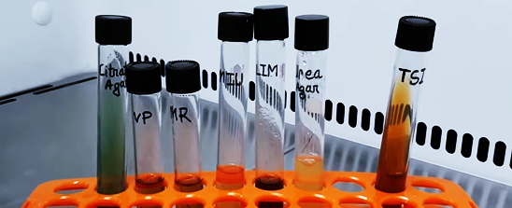

1. Streak Black Colonies on TSA Plate from XLD Culture plate.
2. Streak Black Colonies on TSA Plate from BSA Culture Plate.
3. Now incubate the inoculated TSA plates at 37°C for 24 hours.
4. Inoculate the MR-VP medium with the suspected Salmonella colony for MR test. Attach the cap and rotate the tube to mix the content.
5. Inoculate the MR-VP medium with the suspected Salmonella colony for VP test. Attach the cap and rotate the tube to mix the content.
6. 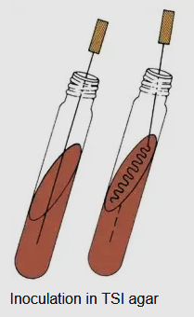Inoculate the slant & butt of TSI with the suspected Salmonella colony. Stub into the butt and then streak on the slant surface of TSI Agar then attach the cap.
7. Inoculate the slant & butt of Simmon citrate Agar with the suspected Salmonella colony. Stub into the butt and then streak on the slant surface.
8. Now stub into the MIU medium without disturbing the surrounding media for motility, indole and urea test.
9. Now stub into the LIM medium to inoculate it for lysin decarboxylation test.
10. Now stub into the Urea Agar medium to inoculate it for urea utilization test.
11. Loose the cap and incubate all of the inoculated tubes at 37°C for 24 hours.

**Observation:**

1. **TSI:** Black color butt is formed due to hydrogen sullite formation and slant turned into red due to dextrose fermentation. The medium is lifted-up from the bottom due to the gas production.

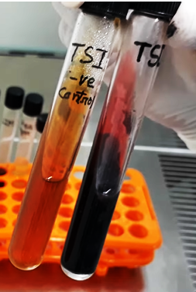

1. **LIM:** The media color is turned into purplish. So. the bacteria showed positive reaction for this test.

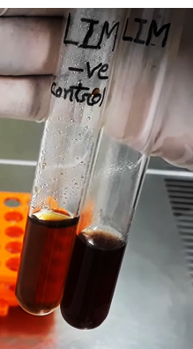

1. **SCA:** The media color is turned into blue from green. So, the bacteria is Citrate positive

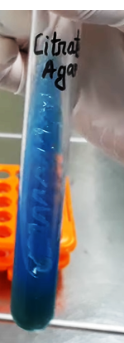

1. **MUI**: Media colour is not turned into pink. So, the bacteria is urea negative. Growth pattern shows the bacterial growth is spread out throughout the media outside of the stub-line. That's why the bacteria is motile. Now, add few drops of Kovacs reagent. No cherry ring is found indicating that the bacteria is indole negative

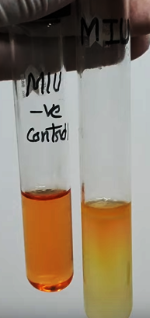

1. **Urea Agar:** No pink color is formed in the Urea Agar. So, the bacteria can't utilize Urea.

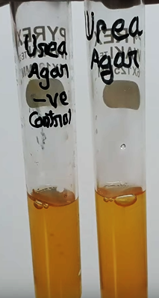

1. **MR:** Add few drops of methyl red solution into the MR tube. Red color development indicates that the bacteria is positive for MR test.

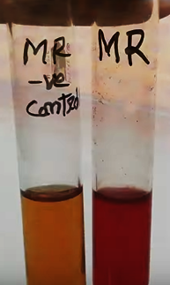

1. **VP:** Add 3 drops of creatine solution. Now, add 2 drops of 1-napthol and finally add 3 drops of potassium hydroxide solution. Close the tube with it's cap and shake slightly to mix the reagents. No pink or red color in 15 min indicates the bacteria is VP negative.

|  |  |  |  |  |  |  |  |  |  |
| --- | --- | --- | --- | --- | --- | --- | --- | --- | --- |
|  | TSI slant | H2S & Gas | Motility test | Indole test | Urea test | Lysine decarboxylase | Citrate Utilization | MR reaction | VP reaction |
| Typical salmonella spp. | Red | +ve | +ve | -ve | -ve | +ve | +ve | +ve | -ve |
| Suspected Bacteria | Red | +ve | +ve | -ve | -ve | +ve | +ve | +ve | -ve |

1. **Aseptic culture technique**

**Materials required:**

1. Distilled water
2. Conical flask
3. Measuring cylinder
4. Mular-Hilton agar media
5. Sprit lamp
6. Lighter
7. Inoculation loop
8. Petri dish
9. Disinfectant (70% Ethanol)

**Procedure**:

1. **Media preparation**: As directed by the media labeling, weigh the mular-hilton agar media. Pour it into a conical flask. Fill it with the necessary volume of water by using a measuring cylinder. Using a piece of cloth to close the conical flask, shake the contents to ensure thorough mixing.
2. **Sterilization**: To eradicate any existing microorganism, autoclave medias and equipment for 15 minutes at 121°C and 101 kPa pressure.
3. Use 70% ethanol to sanitize your hands and to clean the biosafety cabinet's floor. Close the cabinet’s door and turn on the UV lamp to kill any existing microorganisms.
4. After ten minutes, turn off the UV lamp and open the door. Turn on the fan, in order to prevent microorganisms from entering into the biosafety cabinet.
5. After sterilization is complete, remove media and equipment from the autoclave and store them in the biosafety cabinet.
6. Let petri dishes air dry, then close them once the drying process is finished.
7. Fire the spirit lamp, remove the media's covering and burn the top portion in the lamp's flame.
8. Next, fill the petri dish with media up to halfway and close them once the media is solidified.
9. Burn the top portion of inoculation loop over the lamp flame, then cool it by drowning it into the media.
10. Touch the inoculation loop onto the bacteria of another culture media and spread it into new media.
11. Seal the petri dish using paraflim and incubate at 37 $℃$ for 24 hour.

**Observation**

**Composition of Bismuth Sulphite Agar (BSA)**

|  |  |
| --- | --- |
| **Ingredients** | **Gms/liter** |
| Peptone | 10.000 |
| HM Peptone B # | 5.000 |
| Dextrose (Glucose) | 5.000 |
| Disodium phosphate | 4.000 |
| Ferrous sulfate | 0.300 |
| Bismuth sulfite indicator | 8.000 |
| Brilliant green | 0.025 |
| Agar | 20.000 |

**Result Interpretation of Bismuth Sulphite Agar (BSA)**

|  |  |
| --- | --- |
| **Organisms** | **Growth** |
| *Enterobacter aerogenes* | Poor growth; Brown-green (depends on the inoculum density) |
| *Enterococcus faecalis* | Inhibited |
| *Escherichia coli* | Poor growth; Brown-green (depends on the inoculum density) |
| *Salmonella* Enteritidis | Good-luxuriant growth; Black with a metallic sheen |
| *Salmonella* Typhi | Good-luxuriant growth; Black with a metallic sheen |
| *Salmonella* Typhimurium | Good-luxuriant growth; Black with a metallic sheen |
| *Salmonella* Abony | Good-luxuriant growth; Black with a metallic sheen |

**Composition of Triple Sugar Iron (TSI) Agar**

|  |  |
| --- | --- |
| **Ingredients** | **Gms/liter** |
| Pancreatic Digest of Casein | 15.0 |
| Lactose | 10.0 |
| Sucrose | 10.0 |
| Sodium Chloride | 5.0 |
| Peptic Digest of Animal Tissue | 5.0 |
| Yeast Extract | 3.0 |
| Beef Extract | 3.0 |
| Dextrose | 1.0 |
| Ferric Ammonium Citrate | 0.5 |
| Sodium Thiosulfate | 0.3 |
| Phenol Red | 0.024 |
| Agar | 12.0 |

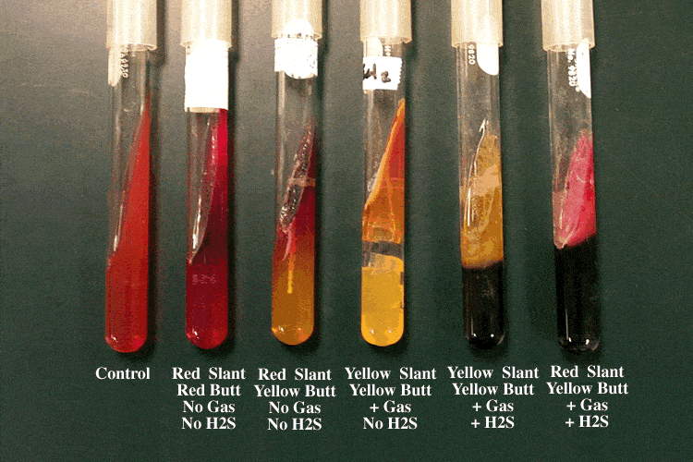

|  |  |  |
| --- | --- | --- |
| **Results (slant/butt)** | **Symbol** | **Interpretation** |
| Red/yellow | K/A | Glucose fermentation only; Peptone catabolized |
| Yellow/yellow | A/A | Glucose and lactose and/or sucrose fermentation |
| Red/red | K/K | No fermentation; Peptone catabolized |
| Red/no color change | K/NC | No fermentation; Peptone used aerobically |
| Yellow/yellow with bubbles | A/A,G | Glucose and lactose and/or sucrose fermentation; Gas produced |
| Red/yellow with bubbles | K/A,G | Glucose fermentation only; Gas produced |
| Red/yellow with bubbles and black precipitate | K/A,G, H2S | Glucose fermentation only; Gas produced; H2S produced |
| Red/yellow with black precipitate | K/A, H2S | Glucose fermentation only; H2S produced |
| Yellow/yellow with black precipitate | A/A, H2S | Glucose and lactose and/or sucrose fermentation; H2S produced |
| No change/no change | NC/NC | No fermentation |
| A=acid production; K=alkaline reaction; G=gas production; H2S=sulfur reduction | | |

|  |  |  |  |  |
| --- | --- | --- | --- | --- |
| **Name of the organism** | **Slant** | **Butt** | **Gas** | **H2S** |
| *Escherichia, Klebsiella, Enterobacter* | Acid (A) | Acid (A) | Pos (+) | Neg (-) |
| *Shigella, Serratia* | Alkaline (K) | Acid (A) | Neg (-) | Neg (-) |
| *Salmonella, Proteus* | Alkaline (K) | Acid (A) | Pos (+) | Pos (+) |
| *Pseudomonas* | Alkaline (K) | Alkaline (K) | Neg (-) | Neg (-) |

|  |  |
| --- | --- |
| **Organisms** | **Growth** |
| *Salmonella enterica* | Growth; red slant, yellow butt, gas positive, black-butt (H2S produced) |
| *Escherichia coli* | Growth; yellow slant, yellow butt, gas positive, no H2S produced |
| *Pseudomonas aeruginosa* | Growth; red slant, red butt, no gas, no H2S produced |
| *Shigella sonnei* | Growth; red slant, yellow butt, no gas, no H2S produced |
| *Citrobacter freundii* | Yellow slant, yellow butt, gas production; positive reaction for H2S Blackening of medium |
| *Enterobacter aerogenes* | Yellow slant, yellow butt, gas production; no H2S produced |
| *Klebsiella pneumoniae* | yellow slant, yellow butt, gas positive, no H2S produced |
| *Proteus vulgaris* | Red slant, yellow butt, no gas production; H2S produced |
| *Salmonella* Paratyphi A | Red slant, yellow butt, gas production; no H2S produced |
| *Salmonella* Typhi | Red slant, yellow butt, no gas production; H2S produced |
| *Salmonella* Typhimurium | Red slant, yellow butt, gas production; H2S produced |
| *Shigella flexneri* | Red slant, yellow butt, gas negative, H2S not produced |

**MR-VP Broth (Glucose Phosphate Broth)**

For performance of Methyl Red and Voges Proskauer tests in differentiation of coli-aerogenes group.

**Composition**

|  |  |
| --- | --- |
| **Ingredients** | **Gms / Litre** |
| Buffered peptone | 7.000 |
| Dextrose | 5.000 |
| Dipotassium phosphate | 5.000 |
| Final pH (at 25°C) | 6.9±0.2 |

|  |  |  |  |
| --- | --- | --- | --- |
| **Organism** | **Growth** | **VP test** | **MR test** |
| Escherichia coli ATCC 25922 | Luxuriant | Negative reaction, no colour change | Positive reaction, bright red colour |
| Enterobacter aerogenes ATCC 13048 | Luxuriant | Positive reaction, eosin pink/red colour | Negative reaction, yellow colour |
| Klebsiella pneumoniae ATCC 23357 | Luxuriant | Positive reaction, eosin pink/red colour | Negative reaction, yellow colour |

**Simmon citrate agar**

|  |  |
| --- | --- |
| **Ingredients** | **Grams per litre** |
| Sodium chloride | 5 |
| Sodium Citrate | 2 |
| [Ammonium dihydrogen  phosphate](https://en.wikipedia.org/wiki/Ammonium_dihydrogen_phosphate) | 1 |
| [Dipotassium phosphate](https://en.wikipedia.org/wiki/Dipotassium_phosphate) | 1 |
| Magnesium sulfate | 0.2 |
| [Bromothymol blue](https://en.wikipedia.org/wiki/Bromothymol_blue) | 0.08 |
| [Agar](https://en.wikipedia.org/wiki/Agar) | 15 |

<https://microbiologyinfo.com/simmons-citrate-agar-composition-principle-uses-preparation-and-result-interpretation/>

**LIM Medium (Lysine, Indole, Motility Medium)**

|  |  |
| --- | --- |
| **Ingredients** | **g/L** |
| Bacteriological agar | 2.7 |
| Bromocresol purple | 0.02 |
| Dextrose | 1 |
| L-Lysine | 10 |
| Peptone | 12.8 |
| Yeast extract | 3 |
| L-Tryptophan | 0.5 |

|  |  |  |
| --- | --- | --- |
| **Microorganisms** | **Specification** | **Characteristic reaction** |
| Enterobacter cloacae ATCC 13047 | Good growth | Lysine (-), Indole (-), Motility (+) |
| Proteus mirabilis ATCC 25933 | Good growth | Lysine (-), Indole (-), Motility (+) |

**Urea Agar**

Composition

|  |  |
| --- | --- |
| **Ingredients** | **Amount** |
| Urea | 20.0g |
| Gelatin Peptone | 1.0 g |
| Sodium Chloride | 5.0g |
| Phenol Red | 12.0 mg |
| Monopotassium Phosphate | 2.0g |
| Agar | 15.0 g |
| Dextrose | 1.0g |
| Demineralized Water | 1000.0 ml |

|  |  |
| --- | --- |
| **Control** | **Results** |
| Cryptococcus neoformans ATCC 34877 | Positive |
| Proteus mirabilis ATCC 12453 | Positive |
| Escherichia coli ATCC 25922 | Negative |

**Kovacs Reagent**

|  |  |
| --- | --- |
| **Ingredients** | **Amount** |
| p-Dimethylaminobenzaldehyde | 5.0 g |
| Isoamyl Alcohol | 75.0 mL |
| Hydrochloric Acid | 25.0 mL |